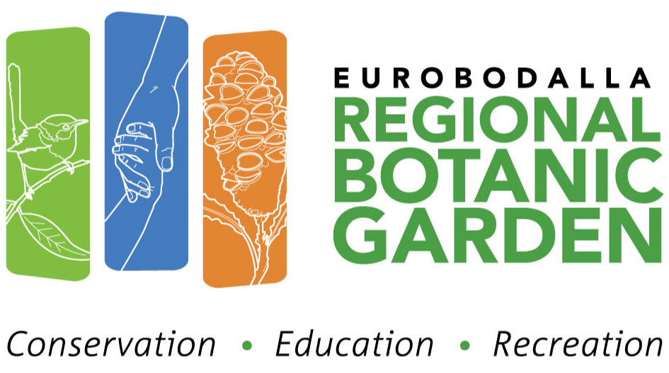

**GUIDED WALK APPLICATION**

Eurobodalla Regional Botanic Garden is nestled in Mogo State Forest and displays the flora of the New South Wales South Coast and adjacent ranges.

Our 12,000 square kilometre collecting area covers the NSW South Coast flora region. From Nowra in the north to the Victorian border in the south, including plants from sea level to sub alpine.

The Garden is also home to a diverse array of fascinating local wildlife including over 100 bird species.

Experience the beauty of Australian Native plants and uncover the secrets and stories of our Garden with our experienced and engaging guides.

The cost of guided walks is $5.40 per person.

Proceeds go to the further development of the garden and its education programs.

TO BOOK A WALK, PLEASE COMPLETE THIS FORM AND SEND TO: [contact@erbg.org.au](mailto:contact@erbg.org.au)

Or phone Visitor Centre – (02) 4471 2544

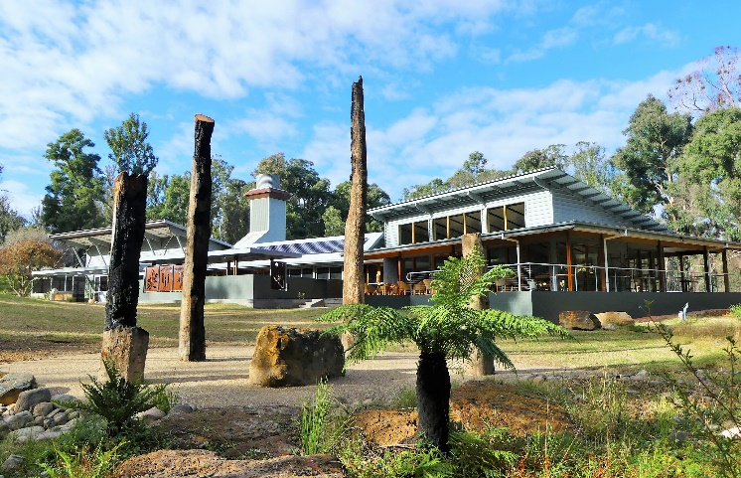

Visit Date : __________________________

Arrival Time: ____________

Tour time from:________ to:________(if not 1 hour)

Number of Visitors: ___________________________

Special needs (e.g. limited mobility – no steps):

____________________________________________

Company Name: ______________________________

Group Name: _________________________________

Group Contact Person: _________________________

Mobile: _____________________________________

Billing Address: _______________________________

___________________________________________

____________________________________________

Phone: _____________________________________

Email: _______________________________________

**BOOKING CONFIRMATION & PAYMENT:**

On receipt of the booking application form, confirmation will be sent. Eurobodalla Shire Council will issue a tax invoice which can be paid online or on the day of the visit; however, at ERBG we can only accept one cash or EFTPOS payment for the full amount covering the entire group.

**CANCELLATIONS AND REFUNDS:**

* Full refund if you cancel the booking at least 7 days prior to the walk
* Full refund if the Gardens are closed due to unsafe conditions
* A butterfly on a flower

  AI-generated content may be incorrect.Refund of payment, less a $30 administration fee, if you cancel the booking within 7 days of the booked walk.